Product Analysis Dashboard

Report submitted in partial fulfillment of the requirement for the degree of

B.Tech

in

Computer Science & Engineering

[](http://www.google.co.in/url?url=http://egov.engineeringwatch.in/bhagwan-parshuram-institute-of-technology-new-delhi-north-west-rohini/&rct=j&frm=1&q=&esrc=s&sa=U&ei=Qcc4VaDfFcOUsAHi54DwDg&ved=0CBUQ9QEwAA&sig2=VGYgGxagdSfRMxejTdK0Yg&usg=AFQjCNFN993UjYXRhdtuExrXVrIGKtxPmw)

by

Swayam

87

Department of CSE

Bhagwan Parshuram Institute of Technology

PSP-4, Sec-17, Rohini, Delhi-89

September 2025

**I**

**DECLARATION**

This is to certify that Report titled “Product analysis dashboard”, is submitted by us in partial fulfillment of the requirement for the award of degree of B.Tech in Computer Science & Engineering to BPIT Rohini Delhi affiliated to GGSIP University, Delhi. It comprises of our original work. The due acknowledgement has been made in the report for using other’s work.

**Date: Name of Student, Enrollment No, Signature**

**24-09-2025 Swayam , 08720802722**

**II**

**Company Certificate**

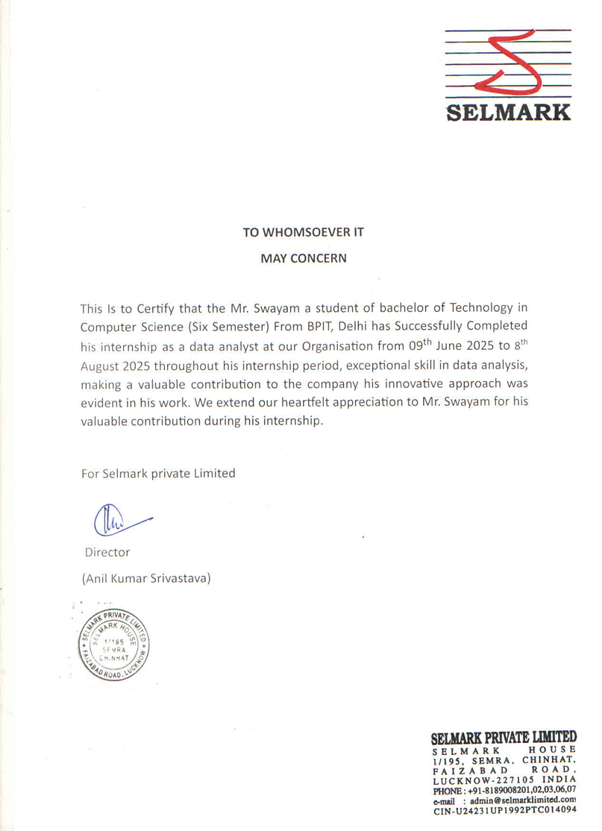

**III**

**Training Coordinator Certificate**

This is to certify that Report titled “Product analysis dashboard” is submitted by **SWAYAM**,08720802722 under the guidance of Mr.Aditya sam Koshy partial fulfillment of the requirement for the award of degree of B.Tech in Computer Science & Engineering to BPIT Rohini affiliated to GGSIP University, Delhi. The matter embodied in this Report is original and has been dully approved for the submission.

**Date: 24/09/2025 Mr.Aditya Sam Koshy**

**IV**

**ACKNOWLEDGEMENT**

No project is ever complete without the guidance of experts who have already navigated this path and become masters of it, serving as leaders. Appreciation is extended to all individuals who contributed to the visualization of this project. Deep gratitude is expressed to project guide and mentor, Prof. Achal Kaushik, for providing timely assistance and invaluable guidance, drawing from his extensive experience in this field. His support has been a guiding light throughout this journey.

Sincere appreciation is also extended to all professors from BPIT and for their valuable insights and tips during the project's design phase. My sincere thanks to Mr. Aditya Sam Koshy for their guidance and feedback. I also appreciate the help from my peers and family for their encouragement and support. Their contributions have been significant in numerous ways, making it difficult to acknowledge each one individually.

Lastly, heartfelt thanks are due to parents, whose unwavering support, encouragement, and love made this work possible.

Date: 24/09/2025 SWAYAM, 08720802722

V

TABLE OF CONTENTS

Title page ........................................................................................................I

Declaration..................................................................................................... II

Company Certificate ................................................................................... III

Training Coordinator Certificate ................................................................. IV

Acknowledgement ........................................................................................ V

Table of contents .........................................................................................VI

Chapters…………………………………………………………………..VII

Abstract ......................................................................................................VIII

VI

Chapters

Chapter 1 : Introduction

1.1: Introduction…………………………………………………..9

1.2: Features of Dashboard

Chapter 2 : Problem Statement…………………………………………….11

Chapter 3 : System Requirement Specifications…………………….12

3.1 : Software Requirement

3.2 :Non-Functional Requirements

Chapter 4.1 : Methodology ………………..…………………………...…14

4.1.1 :Data Collection

4.1.2 : Data Pre-Processing & Storage

4.1.3 :code

4.1.4 :Database Integration

4.1.5 :Data Transformation in Power BI

4.1.6: Visualization and Dashboard Creation

4.2 :Implementation

4.2.1.Database   
 4.2.2. Power BI Connection

4.2.3.Dashboard Development

Chapter 5 : use case…………………………………………………..…27

Chapter 6 : conclusion…………………………………………………..31

6.1Conclusion

6.2 Limitations and Future Scope

REFERENCES ………………………………………………………………..…33

VII

ABSTRACT

This project presents the development of a comprehensive product analysis dashboard using Power BI, aimed at facilitating data-driven decision-making for businesses. The dashboard integrates multiple datasets, including sales, product, and discount information, through SQL, enabling real-time visualization and analysis. Key features include interactive charts, filters, and drill-down capabilities that allow users to explore product performance, identify trends, and assess the impact of discounts on sales. The dashboard provides actionable insights for managers and stakeholders to optimize strategies, improve efficiency, and enhance overall business performance. While primarily focused on descriptive analytics, the framework lays the foundation for future enhancements such as predictive modeling, real-time data updates, and advanced KPI integration.

VIII

CHAPTER 1

1. Introduction

In today’s competitive business environment, organizations generate vast amounts of data from different sales channels and products. Analyzing this data is crucial for making informed decisions that drive revenue, profit, and overall business growth. To address this need, a Product Analytics Dashboard was developed using Power BI. The dashboard provides stakeholders with a centralized, interactive, and real-time view of key business metrics such as revenue, profit, and sales trends. This enables decision-makers to identify patterns, monitor performance, and take timely corrective actions.In today’s fiercely competitive business environment, organizations are constantly inundated with an overwhelming volume of data stemming from a multitude of diverse sales channels and an ever-expanding portfolio of products. The ability to effectively analyze this vast ocean of information is no longer a luxury but a critical imperative for making astute, data-driven decisions that are foundational to driving sustained revenue growth, maximizing profit margins, and ensuring overall business prosperity.

To precisely address this pressing organizational need for enhanced data visibility and actionable insights, a sophisticated Product Analytics Dashboard has been meticulously developed. This powerful tool leverages the advanced capabilities of Power BI, a leading business intelligence platform renowned for its robust data visualization and analytical functionalities.

The primary objective of this dashboard is to provide all relevant stakeholders—ranging from sales managers and marketing executives to product developers and senior leadership—with a centralized, highly interactive, and real-time view of the most crucial business metrics. Key performance indicators (KPIs) such as revenue, profit, and sales trends are prominently displayed and meticulously tracked.

This comprehensive and dynamic dashboard empowers decision-makers to effortlessly identify emerging patterns and trends within their sales data, accurately monitor the performance of individual products and sales channels, and most importantly, take timely and decisive corrective actions when performance deviates from established targets. By offering a unified and easily digestible perspective on complex data, the Product Analytics Dashboard significantly enhances an organization's capacity for strategic planning, operational efficiency, and ultimately, sustained market leadership.

---

## 1.2.Features of the Dashboard

* Revenue Analysis: Tracks overall revenue and highlights top-performing products.
* Profit Trends: Displays net profit, profit margins, and profitability across different categories.
* Sales Trends: Provides monthly, quarterly, and yearly sales comparisons to identify growth patterns.
* Interactive Visualizations: Dynamic charts, graphs, and filters allow stakeholders to drill down into specific products, regions, or time frames.
* KPIs (Key Performance Indicators): Clear indicators for revenue, profit, and sales growth rates.
* Comparative Analysis: Year-over-year and month-over-month comparisons for better understanding of business performance.
* User-Friendly Interface: Simple and intuitive design for non-technical stakeholders.

CHAPTER 2

2.1 Problem

In today’s competitive business environment, organizations generate huge volumes of sales and revenue data. However, raw data alone does not provide meaningful insights for decision-making. Stakeholders often face these challenges:

1. Difficulty in Understanding Trends  
   * Sales data spread across different periods makes it hard to track year-over-year (YoY) growth or decline.
2. Limited Visibility into Profitability  
   * Without proper visualization, it is difficult to analyze profit margins and identify the most profitable products or regions.
3. Inefficient Reporting  
   * Manual reports in Excel are time-consuming and prone to errors, delaying strategic decisions.
4. Lack of Actionable Insights  
   * Business leaders require quick insights into sales volume, revenue patterns, and profit trends to make timely interventions.

Stakeholders need a centralized, interactive, and visual analytics dashboard that transforms raw data into clear, actionable insights on sales, revenue, and profit trends to support better decision-making.

CHAPTER 3

3.1 System Requirement Specifications

1. Hardware Requirements

* Processor: Intel i5 or higher (or equivalent AMD processor)
* RAM: Minimum 8 GB (recommended 16 GB for large datasets)
* Storage: 500 GB HDD or 256 GB SSD
* Graphics: Integrated graphics sufficient for Power BI (dedicated GPU optional)
* Monitor: 1080p resolution (better for dashboard visualization)

### 2. Software Requirements

* Operating System: Windows 10/11 (Power BI Desktop works best on Windows)
* Power BI Desktop (latest version)
* Microsoft Excel (for preprocessing and data cleaning, if required)
* SQL Server/MySQL (optional, if connecting directly to databases)
* Python (optional, for advanced preprocessing or integration)

3.2 Non-Functional Requirements

1.Performance

* Dashboard should load within 5–10 seconds for datasets under 1 million rows.
* Queries and filters should update visuals in near real-time.

2.Scalability

* Should support increasing data volume (monthly/yearly sales records).
* Able to integrate with larger databases in the future.

3.Usability

* Dashboard must have a clean, intuitive layout for non-technical stakeholders.
* Filters, slicers, and visuals should be easy to interact with.

4.Reliability

* Dashboard should always show accurate and consistent insights.
* Error handling for missing or corrupted data.

5.Security

* Role-based access (view-only vs edit rights).
* If deployed online (Power BI Service), ensure secure login with Microsoft accounts.

6.Maintainability

* Easy to update dataset connections and refresh data without rebuilding visuals.
* Documentation provided for future maintenance.

7.Portability

* Should run smoothly on any standard Windows system with Power BI installed.
* Future option to deploy on Power BI Service for cross-platform access.

CHAPTER 4

## 4.Methodology

4.1.Data Collection  
:

1. Product Data – containing product categories, IDs, names, etc.

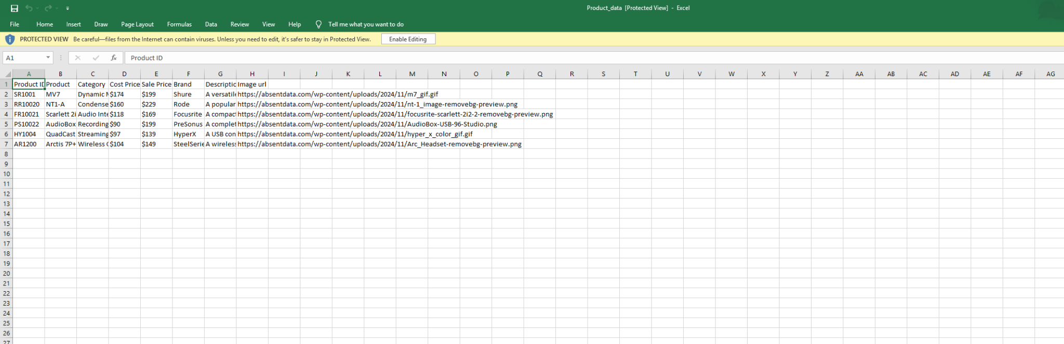

2 . Sales Data – containing order details, sales amount, profit, quantity,

region,etc.

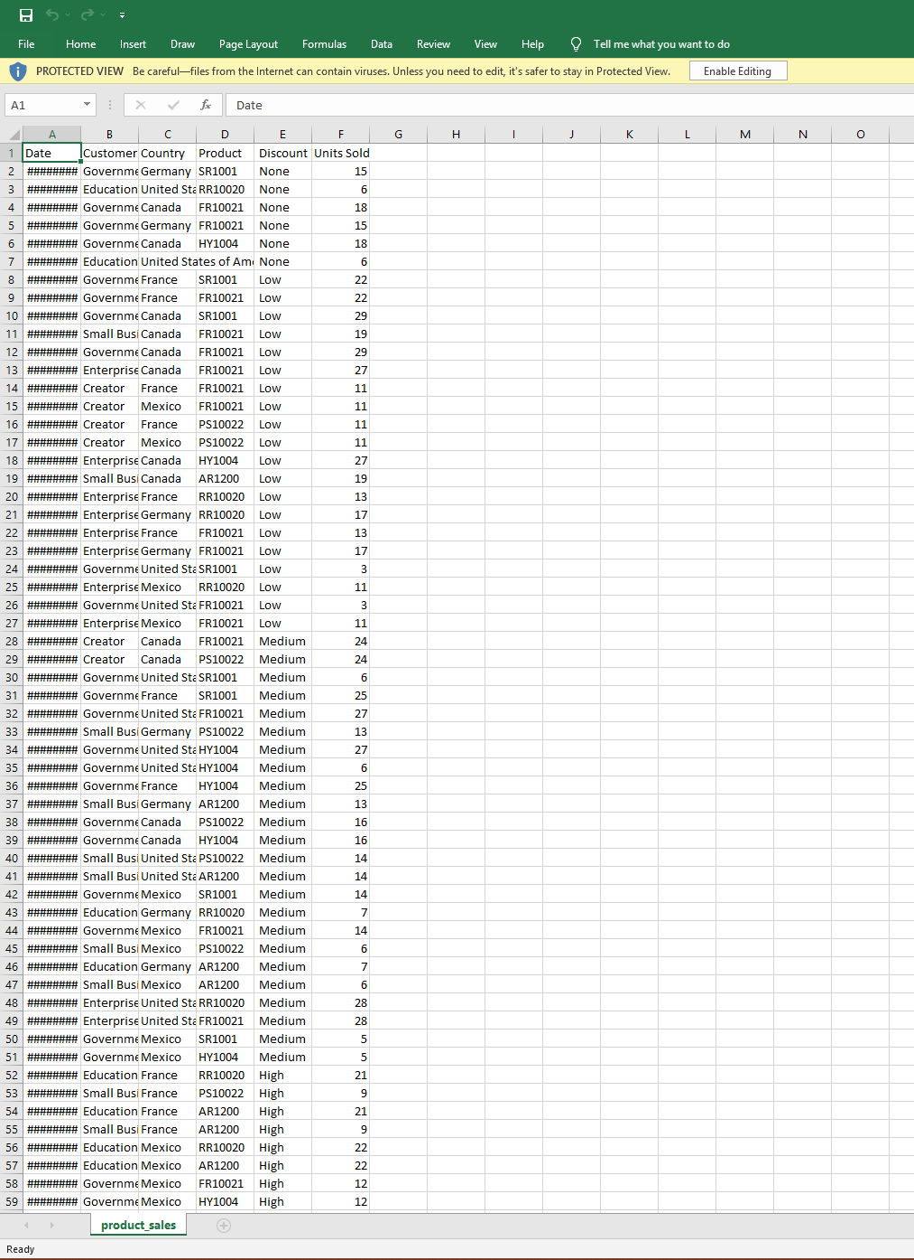

3. Discount Data – containing discount rates applied on different products.

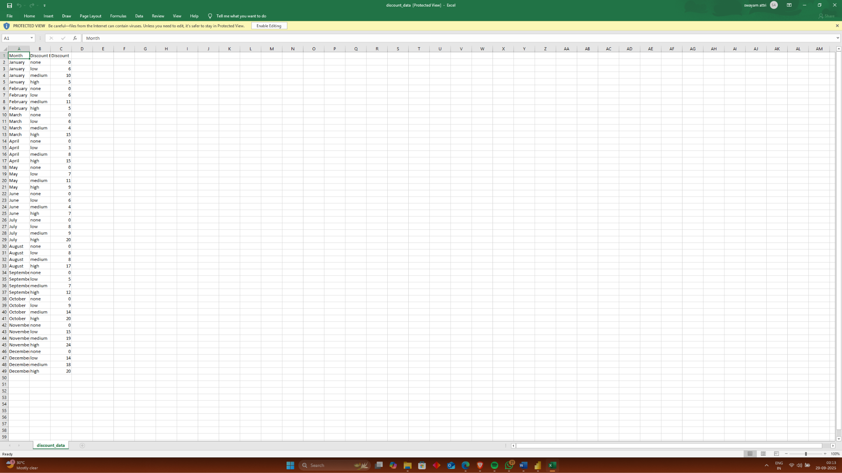

4.2 Data Pre-Processing & Storage

* The raw CSV files were imported into SQL Server/MySQL to create a centralized database.
* A schema was designed to represent relationships between sales, products, and discounts.
* SQL scripts were written to:  
  + Create tables (Products, Sales, Discounts).
  + Insert and clean data.
  + Apply primary/foreign key constraints to maintain referential integrity.

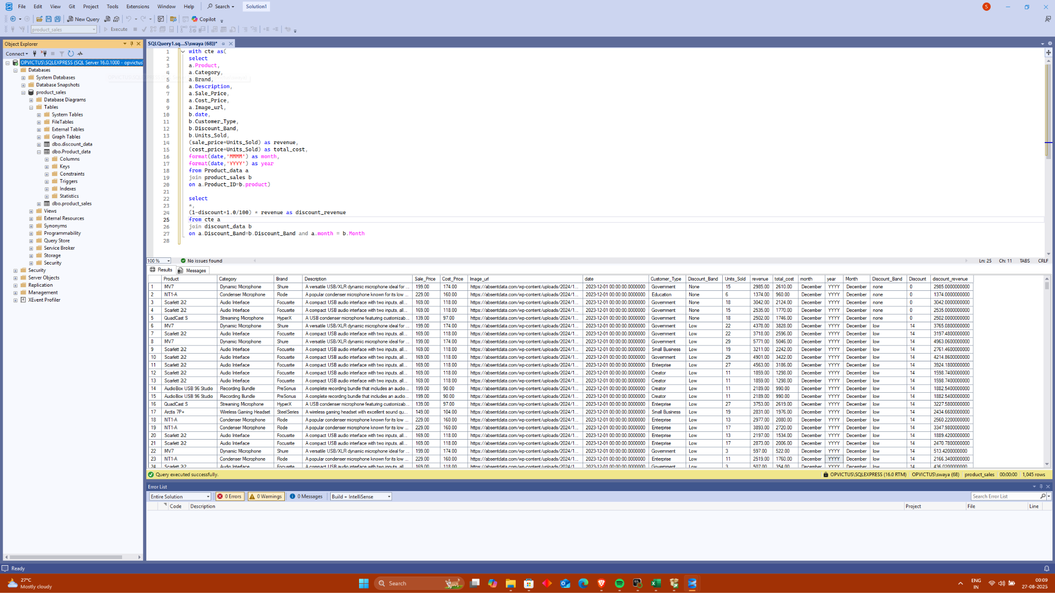

4.3.Code

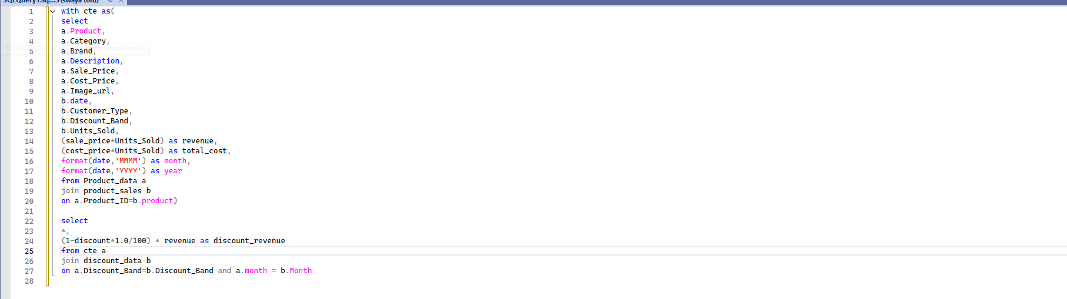

**CODE**

with cte as(

select

a.Product,

a.Category,

a.Brand,

a.Description,

a.Sale_Price,

a.Cost_Price,

a.Image_url,

b.date,

b.Customer_Type,

b.Discount_Band,

b.Units_Sold,

(sale_price*Units_Sold) as revenue,

(cost_price*Units_Sold) as total_cost,

format(date,'MMMM') as month,

format(date,'YYYY') as year

from Product_data a

join product_sales b

on a.Product_ID=b.product)

select

*,

(1-discount*1.0/100) * revenue as discount_revenue

from cte a

join discount_data b

on a.Discount_Band=b.Discount_Band and a.month = b.Month

4.4.Database Integration

* Once the database was created and cleaned, it was connected to Power BI using the SQL connector.
* Queries were written to fetch live data directly from the database.
* This ensured that any updates in the SQL database would be reflected in the dashboard.

4.5.Data Transformation in Power BI

* Using Power Query Editor, additional transformations were applied:  
  + Removing null values.
  + Formatting date and currency fields.
  + Creating calculated measures (e.g., profit margin, YoY sales growth).
* Relationships between tables were established in the Power BI model.

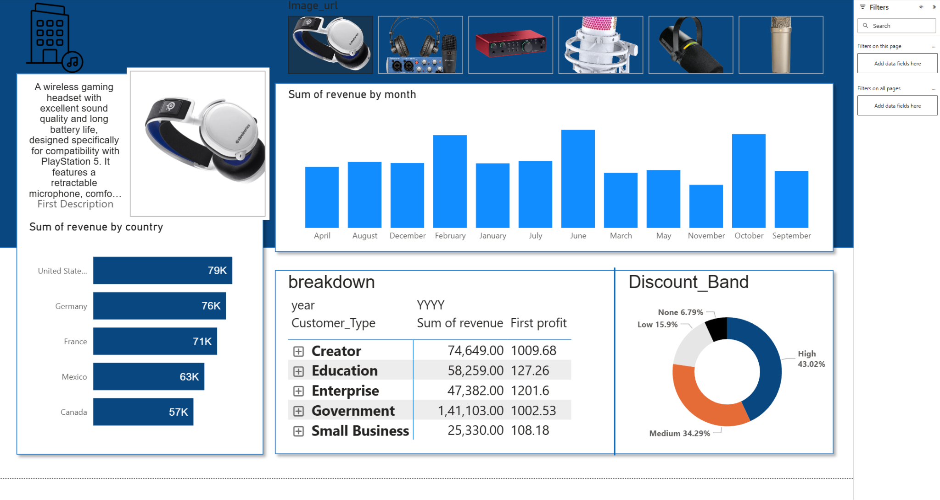

4.6.Visualization and Dashboard Creation

* Interactive visualizations were built in Power BI to analyze key performance indicators:  
  + Sales Volume Analysis (Year-on-Year)
  + Profit Trends by Region/Product
  + Impact of Discounts on Sales
  + Top Performing Products
* Filters and slicers were added for dynamic exploration

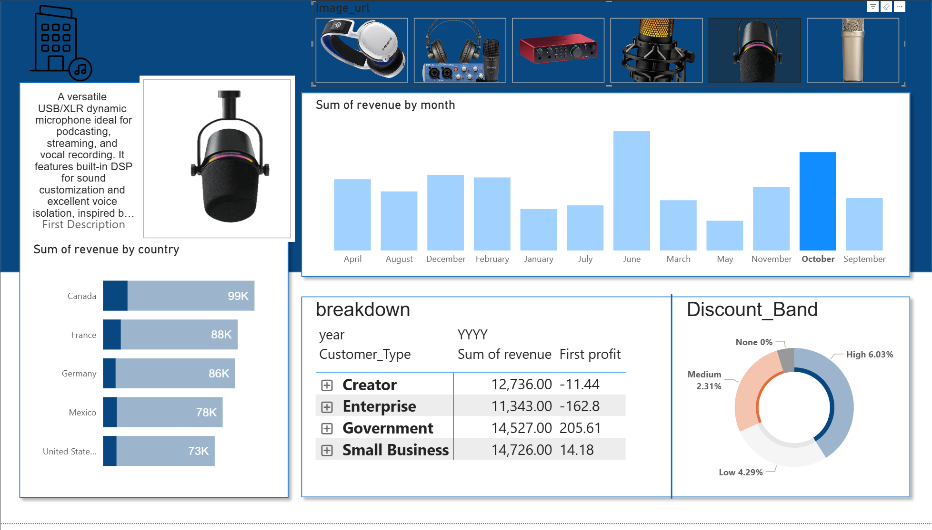

4.2. Implementation

4.2.1.Database Setup (SQL Script)

* + Created database schema with Products, Sales, and Discounts tables.
  + Loaded data from CSV files into tables using LOAD DATA INFILE (MySQL) or BULK INSERT (SQL Server).
  + Wrote SQL joins and queries to merge datasets and prepare for Power BI connection.

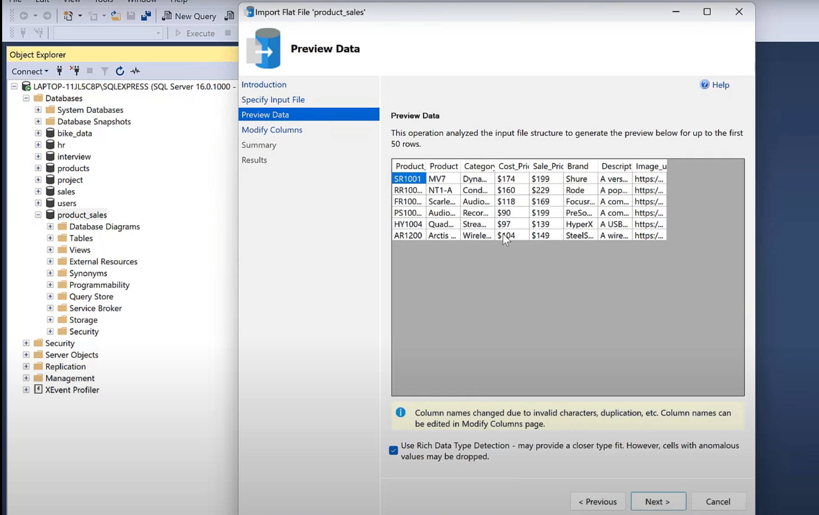

Putting excel csv files data in sql database

Example:

SELECT s.SaleID, p.ProductName, s.Quantity, s.SalesAmount,

d.DiscountPercent, (s.SalesAmount - (s.SalesAmount * d.DiscountPercent/100)) AS NetSales,

s.Profit, s.OrderDate

FROM Sales s

JOIN Products p ON s.ProductID = p.ProductID

LEFT JOIN Discounts d ON s.DiscountID = d.DiscountID;

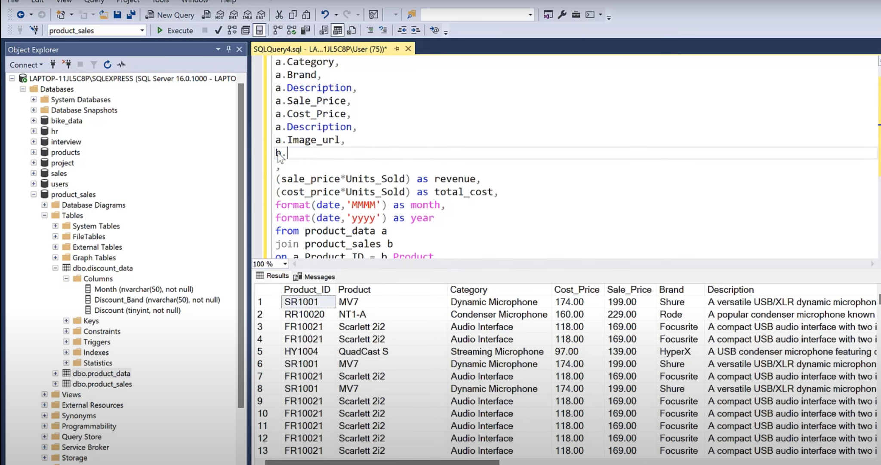

4.2.2. Power BI Connection

* + Connected SQL Database → Imported above query results.
  + Built relationships between fact (Sales) and dimension (Products, Discounts) tables.

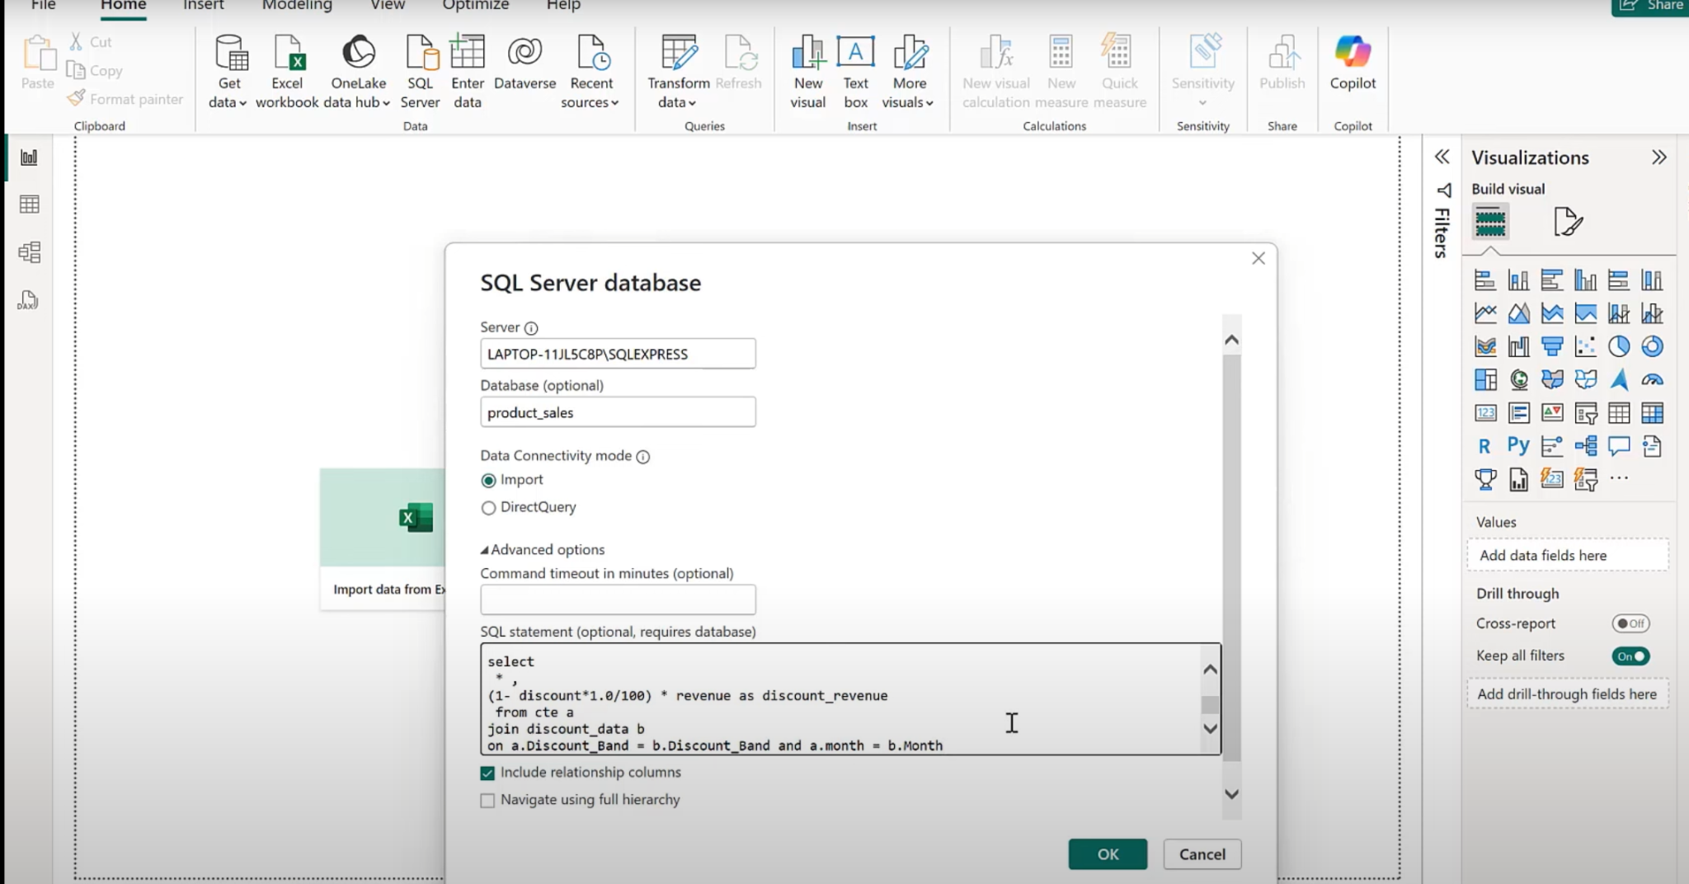

Connecting sql database with Power BI

4.2.3.Dashboard Development

* + Used bar charts, line charts, cards, and slicers to present KPIs.

Implemented calculated measures in DAX, e.g.:  
  
 ProfitMargin = DIVIDE(SUM(Sales[Profit]), SUM(Sales[SalesAmount]))

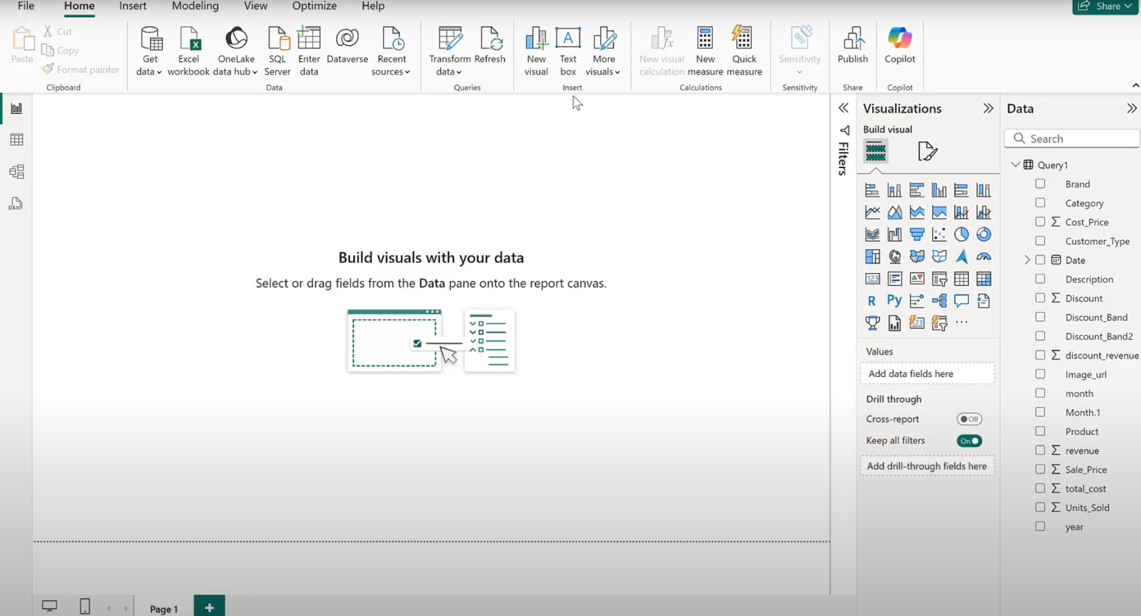

Starting power BI for dashboard

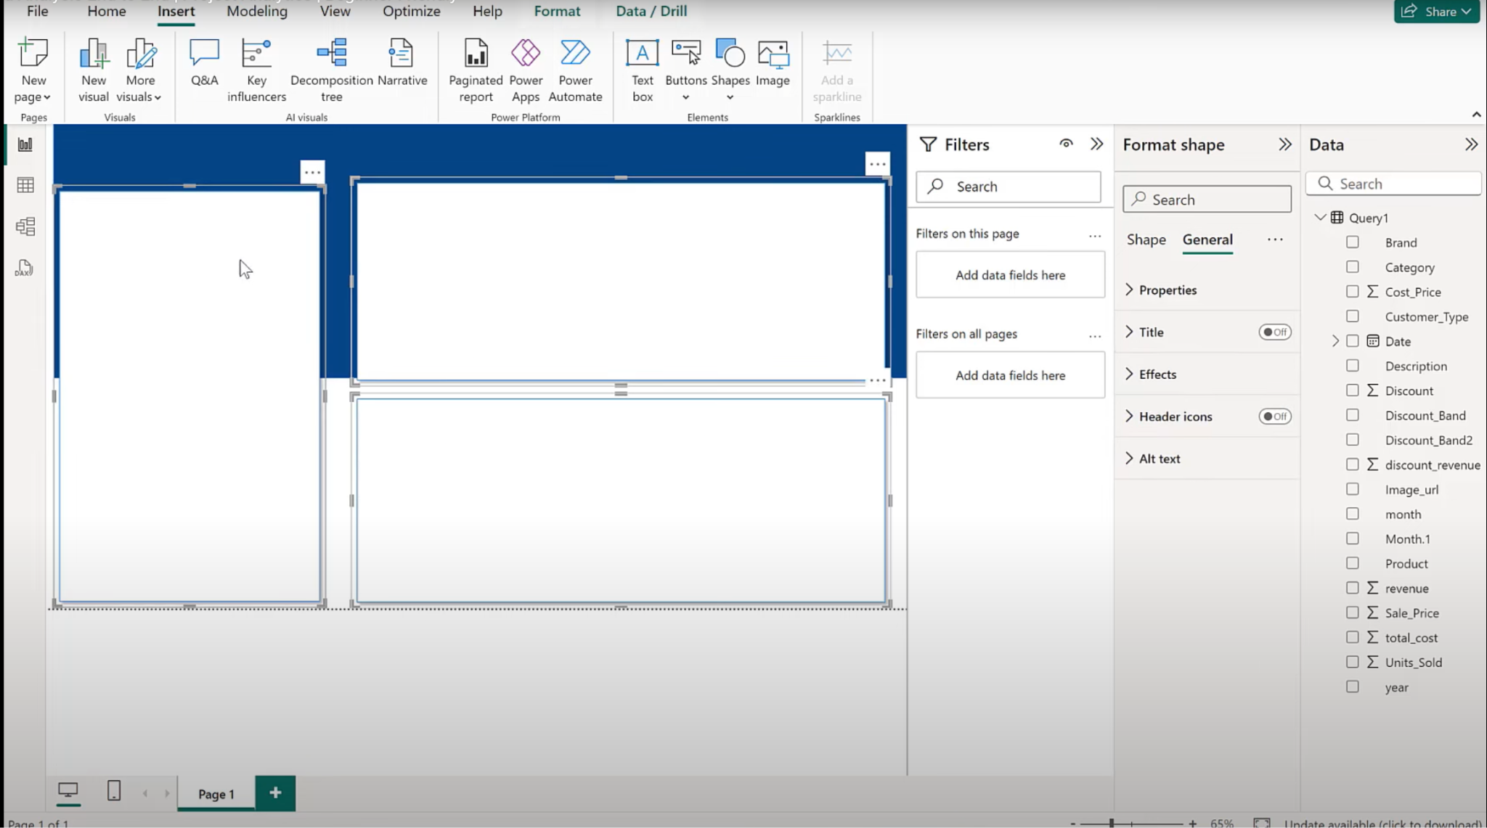

Making a professional looking dashboard

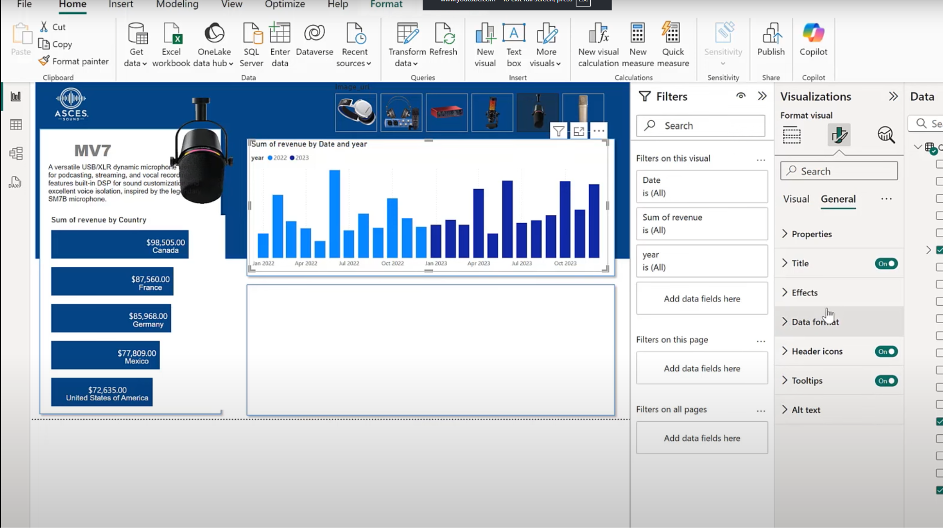

Putting important aspects of data for easy visualisation

CHAPTER 5

# 5.USE CASE

The developed Sales Analysis Dashboard using SQL and Power BI is designed to provide a comprehensive view of organizational sales performance. By integrating data from multiple sources (Products, Sales, Discounts), the system allows business users to monitor performance metrics, identify trends, and support data-driven decision-making.

### 1. Sales Performance Monitoring

* Actor: Sales Manager / Business Owner
* Objective: To evaluate sales revenue and profit trends over different time periods.
* Description:  
   The user logs into Power BI and interacts with the dashboard to view the Year-on-Year sales volume, profit margins, and net revenue. With filters for region, category, and time frame, the manager can pinpoint the strongest and weakest areas.
* Benefit: Helps in identifying high-growth markets and regions where performance is declining. Supports strategic decision-making such as resource allocation or re-targeting campaigns.

### 2. Product Performance Analysis

* Actor: Product Analyst / Inventory Manager
* Objective: To assess the contribution of individual products or categories towards revenue and profitability.
* Description:  
   By applying slicers on the dashboard, the user can analyze which products generate the maximum profit and which are underperforming. The system highlights top-performing products and provides insights into the impact of discounts on product sales.
* Benefit: Allows businesses to optimize product portfolios, promote profitable items, and discontinue low-performing ones.

### 3. Discount Effectiveness Measurement

* Actor: Marketing / Sales Promotion Team
* Objective: To evaluate whether applied discounts are increasing sales volume or reducing profitability.
* Description:  
   Using the integrated dataset of sales and discount tables, the dashboard presents comparisons of sales with discounts vs. without discounts. Users can visualize if discounts actually lead to higher profits or just increased volume with lower margins.
* Benefit: Enables smarter discount strategies, ensuring that promotions drive sustainable profit growth rather than just temporary volume spikes.

### 4. Regional Sales Insights

* Actor: Regional Manager / Business Head
* Objective: To identify which geographic regions contribute most to the business.
* Description:  
   The dashboard provides region-wise breakdown of sales, profit, and order quantities. With comparative visuals, regional managers can benchmark performance across areas.
* Benefit: Assists in regional planning, targeted campaigns, and inventory allocation.

### 5. Strategic Decision-Making for Future Planning

* Actor: Senior Management / Stakeholders
* Objective: To use consolidated insights for long-term strategy.
* Description:  
   By reviewing the dashboard, senior stakeholders gain a bird’s-eye view of the company’s performance. They can analyze year-over-year growth, overall profitability, and the effectiveness of marketing campaigns.
* Benefit: Provides evidence-based support for strategic planning, investment, and expansion decisions.

The system is not limited to simple reporting; it serves as an interactive decision-support tool. Unlike static Excel sheets, the dashboard offers dynamic filtering, drill-down analysis, and real-time updates from the SQL database. This means that instead of merely recording past performance, the solution enables proactive monitoring and forecasting.

Moreover, the design of the dashboard ensures ease of usability. Even a non-technical user can operate slicers, change views, and generate insights without needing to write SQL queries manually. This lowers the technical barrier for business users and democratizes access to analytics within the organization.

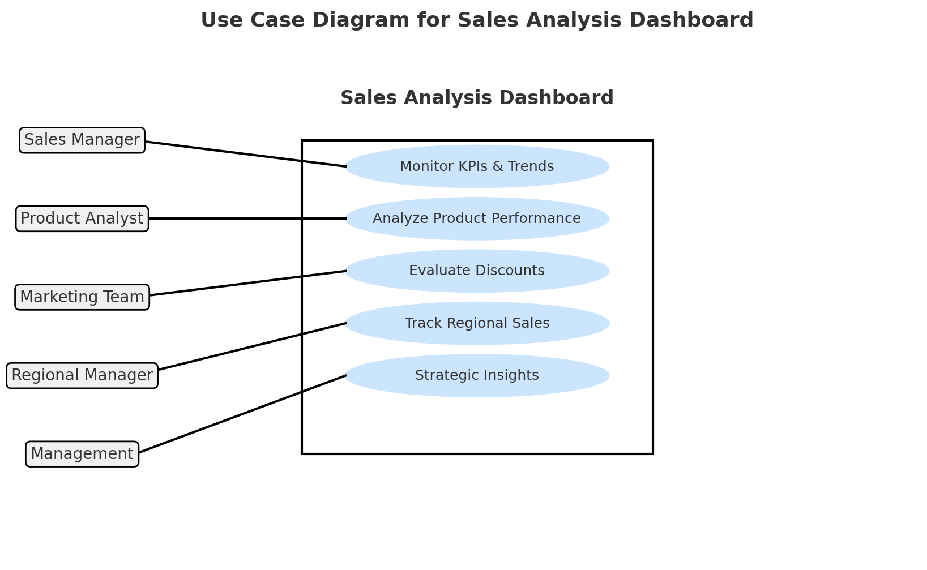

CHAPTER 6

6.1 Conclusion

The product analysis dashboard developed in Power BI successfully consolidates and visualizes key metrics related to sales, discounts, and product performance. By integrating multiple data sources through SQL, the dashboard provides real-time insights, enabling users to make data-driven decisions efficiently. The interactive features such as filters, slicers, and drill-down options allow for detailed analysis at various levels, helping identify trends, high-performing products, and areas requiring improvement. Overall, the dashboard serves as a practical tool for managers and stakeholders to monitor performance, optimize strategies, and enhance overall business outcomes.

6.2 Limitations and Future Scope

Limitations:

1. Data Dependency: The dashboard’s accuracy is directly dependent on the quality and completeness of the input data. Incomplete or inconsistent data can lead to misleading insights.
2. Performance Issues: With extremely large datasets, the dashboard may experience slower loading times, affecting usability.
3. Limited Predictive Capabilities: The current dashboard primarily focuses on descriptive analytics and lacks advanced predictive or prescriptive features.
4. User Training Requirement: Some users may require guidance to fully utilize all interactive features of the dashboard.

Future Scope:

1. Integration of Predictive Analytics: Incorporating machine learning models to forecast sales trends or product demand could enhance decision-making.
2. Real-Time Data Updates: Linking the dashboard to live transactional data sources can provide more timely insights.
3. Enhanced Customization: Adding more personalized views or user-specific reports for different departments can improve usability.
4. Mobile Accessibility: Developing a mobile-friendly version would allow stakeholders to access insights on the go.
5. Incorporation of Additional KPIs: Future iterations could include metrics like customer segmentation, profit margins, and inventory turnover to provide a more comprehensive analysis.

REFERENCES

**Microsoft Power BI Documentation**

* <https://docs.microsoft.com/en-us/power-bi/>

**SQL Tutorial - W3Schools**

* <https://www.w3schools.com/sql/>

**Data Analysis Expressions (DAX) Reference - Microsoft**

* <https://docs.microsoft.com/en-us/dax/>

**Introduction to Data Modeling for Power BI - SQLBI**

* [https://www.sqlbi.com/articles/data-modeling-for-power-bi/](https://www.google.com/search?q=https://www.sqlbi.com/articles/data-modeling-for-power-bi/)

**Power Query M formula language reference - Microsoft**

* <https://docs.microsoft.com/en-us/powerquery-m/>